MSJC SUMMER SHOW
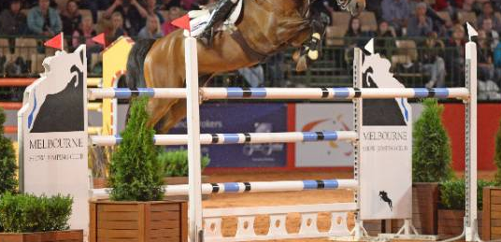
Saturday March 5th 2016
Two sand rings commencing Ring 2 at 8:00am SHARP
Ring 1 will run in draw order & commence at 9.00am SHARP
- Catering will be available by Oaklands Pony Club -
*MSJC members who help out on the day will receive one free lesson*
Helpers must report to the office and notify staff
NO DOGS ALLOWED ON PROPERTY
All Entries On-line ONLY
www.globalentriesonline.com.au Open 8th February Close Wednesday 2nd March at 9pm
No entries on the day
Code Red or Severe weather will result in show cancellation and entry refund

*Three events/classes allowed on the day per horse

RING 1
Course Designer-David Sheppard
Start time 9.00am SHARP
ALL CLASSES IN RING 1 WILL BE RUN IN DRAW ORDER as published on Global
Horses must have EV cards and be currently registered with EA for ALL classes in this ring
1. Racing Victoria 1.05-1.10m Class AM5 - Art 238 2.2
1st $60.00 2nd $40.00 3rd $30.00 4th $25.00 5th $15.00 6th$15.00
Entry fee: $10.00
-
2 Supreme Caravans 1.10-1.15m Class AM5 - Art 238 2.2
1st $100.00 2nd $60.00 3rd $40.00 4th $20.00 5th $15.00 6th $15.00
Entry fee: $15.00-
3. 1.10-1.20m Table C Scurry Art 263, Art 239
Sponsored by Brian & Anne Jones
1st $100.00 2nd $60.00 3rd $40.00 4th $20.00 5th $15.00 6th $15.00
Entry fee: $15.00
4. 1.20- 1.25m Class AM5 Art 238 2.2
Sponsored by Kathleen & Richard Cust
1st $100.00 2nd $60.00 3rd $40.00 4th $20.00 5th $15.00 6th $15.00
Entry fee: $15.00
5. Robbie Allen Championship 1.20-1.35m AM5 - Art 238 2.2
Sponsored by Melbourne Show Jumping Club
1st $200.00 & Perpetual Trophy Replica, 2nd $150.00 3rd $100.00 4th $70.00
Entry fee: $20.00
Alpha Dog Beds $20.00 Voucher awarded to each winner in Ring 1
- Most successful Junior on the day – Vipa Vest. Donated by Greg & Diane Childs – VIPA Vests -
- Best Performed Retired Racehorse – Rug sponsored by Racing Victoria - Thoroughbred racing name is required on Global Entries to be eligible for the award.
* Best Presented combination in Ring 1 decided on by Judge

RING 2

Course Designer-Jenny Muir & Assistants
Start time: 8:00am SHARP
All Competitors MUST be current members of Melbourne Show Jumping Club
or EV or PCAV
Horses may only compete ONCE in each class

Ring Sponsor Pringle Automotive
5. 90cm Competition Two Phase - Art 274 5.2
1st $30.00 2nd $20.00 3rd $10.00 4th $10.00 5th $10.00 6th $10.00
Entry Fee: $10.00
6. 1.00metre Competition Two Phase - Art 274 5.2
1st $30.00 2nd $20.00 3rd $10.00 4th $10.00 5th $10.00 6th $10.00
Entry fee: $10.00
-
7. 1.04metre Competition AM5 - Art 238 2.2
1st $30.00 2nd $20.00 3rd $10.00 4th $10.00 5th $10.00 6th $10.00
Entry fee: $10.00
-
8 70cm Competition Super Two Phase - Art 274 5.6
1st $30.00 2nd $20.00 3rd $10.00 4th $10.00 5th $10.00 6th $10.00
Entry fee: $10.00
9. MSJC 80cm Competition Two Phase – Art 274 5.2
1st $30.00 2nd $20.00 3rd $10.00 4th $10.00 5th $10.00 6th $10.00
Entry fee: $10.00
Hygain Product to each winner in Ring 2
Alpha Dog Beds $20.00 Voucher to each 2nd place in Ring 2
* Best Presented combination in Ring 2 decided on by Judge

Location
Sherwood, Oaklands Hunt Club
1040 Somerton Road, Oaklands Junction.
Melways Ref: 178 C6

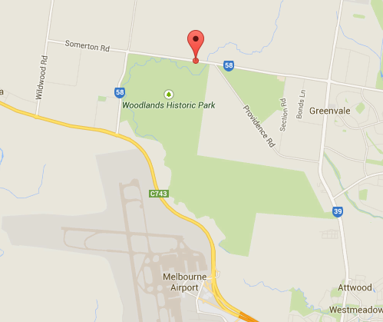

Contact/Enquiries:
Jenny Muir: 03 9714 8340
Greta Prosenik: 0409 183 133

RULES AND REGULATIONS
- All riders must be current (2015-2016) members of MSJC, EA or an offical jumping club or PCAV for insurance purposes.
Valid MSJC membership: Single $30.00 Family $50.00 paid since July 1st 2015
- Any person mounted upon a horse must be wearing a properly secured approved helmet and correct footwear.
- Entries are to be lodged & paid on www.globalentriesonline.com.au Close Wednesday 2nd March 2016 at 9pm. NO ENTRIES ON THE DAY.
- All riders and owners in official classes Ring 1 must be financial members of EA to compete and all horses in Ring 1 must hold current registration and grading cards.
- All riders in Ring 2 MUST be financial MSJC, EV or PCAV members
- Prize money will NOT be given out in official classes unless grading cards have been sighted by the judge.
- Dress standard as per EA regulations or FULL Pony Club or Adult Riding uniform.
- Presentations will be mounted and riders are expected to wear jackets.
- The committee reserves the right to alter events or refuse entries.
- The cross country fences are NOT to be jumped under any circumstances.
- Please take home ALL MANURE in the bags provided.
- EA stallion regulations (January 2011) will be enforced. Green disks essential.
- Three events/classes allowed on the day per horse.
- Camping available on the grounds – No Showers. Phone Darren Green (0488032220) for information concerning nearby stabling and yards.
- NO DOGS ALLOWED ANY ONE WITH A DOG WILL BE ASKED TO LEAVE. This property belongs to the Oaklands Hunt Club.
- If a Code Red or Severe (Total Fire Ban) weather alert is issued for the Central Fire Region, the show will be cancelled and all monies will be refunded.
Neither the organising committee of the Melbourne Show Jumping Club Inc, nor the Oaklands Hunt Club Inc, nor Oaklands Pony Club Inc accept any liability for any accident, damage, injury or illness to horses, riders, owners, officials, spectators or any person or property whatsoever. Horses and riders compete at their own risk.
Special thanks to Oaklands Hunt Club Inc for the use of their wonderful facilities and the Oaklands Pony Club Inc for providing the canteen and their ongoing support.

Sponsors

Melbourne Show Jumping Club acknowledge the following companies and organisations for their support for our 2016 Summer Show. Without our wonderful sponsors, we would be unable to run such a great show. Please support the sponsors who support you!
BULLA PRODUCE
Kathleen & Richard Cust
Alpha Dog Beds

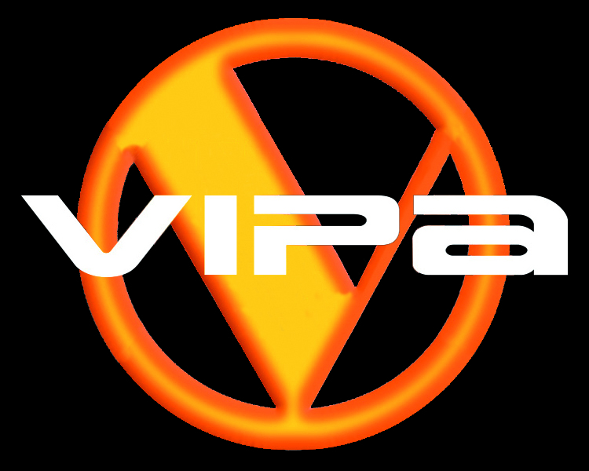

Makers of Safety Vests for Riders
16 Ainslie Road Campbellfield Vic Phone: (03) 93575591
Restorers of the Judging Van and Builders of the Training Day Trailer

B & A Jones. Wandi Park, Willowmavin

