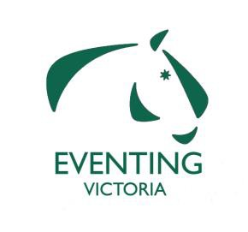
EVENTING VICTORIA STATE SQUADS

APPLICATION FORM FOR 2016 SQUADS

Name: DOB (YR applicants):

EV Number: Contact Number:

Email address___________________________________________

I would like to apply for the 2016 Squad on the following horse/s

1. EV:

2. EV:

We would like you to include your 2 best performances in EA classes at
Horse Trials competitions during 2014.

1.

2.

Best score at a CCI in 2015.Event…………………………….Level……

Applications Close Tuesday 15th of December 2015- Applications can be emailed to Karen Amore eventing@equestrianvictoria.com.au or posted to- EQUESTRIAN VICTORIA
PO BOX 616 WERRIBEE VICTORIA 3030
Karen Amore Eventing Coordinator
(03) 9013 0707

Name: __________________________________________ EV Membership #:____________________
Postal Address: ___________________________________________________Post Code: ___________
Daytime Phone: ___________________________________ Email: ______________________________
Credit Card Type: VISA □ or MASTERCARD □ Total:$ 50
Card Holder Name: ____________________________ Signature: _______________________________

Expiry Date: __ __ / __ __ Card #: __ __ __ __ /__ __ __ __ /__ __ __ __ /__ __ __ __ /

