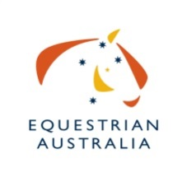
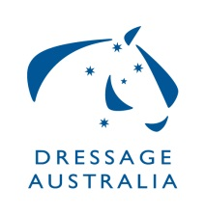
EA Dressage Judge Application Form &

Pre Requisites Required To Fast Track To

D Level

(To be completed by the upgrading judge)
Assessment Slip | Date/Location |  |  |  |  | Name - JE/Mentor/SDA |  |  | Signature
Attend an seminar that includes D Level | Date:
 | Location:
Complete the current ORBT with at least 90% | Date:
 | Percentage:
Medium Theory Exam Completed with 80% Pass Mark | Date:
 | Percentage:
Complete Generic Units  (Compulsory)  Note: Units 1, 4 & 5 will be covered in your E level seminar  Units 2 and 3 may be done online | Unit 1 – EA/NOAS
Unit 2 – Conflict Resolution
https://learning.ausport.gov.au/jportal/default.aspx
Unit 3 – Safety & Risk Management
https://learning.ausport.gov.au/jportal/default.aspx
 | Unit 4 – Ethical Issues
 | Unit 5 – Horse Welfare
Sit in on 2 separate occasions at Medium level with a different Judge Educator  Sit in assessment forms completed/attached | 1.
 | 2.
Assessment Slip | Date/ Location |  |  |  |  | JE/Mentor/SDA/Name | JE Signature
Assessment slips go directly to the State Dressage Authority for verification with this summary sheet. Results are forwarded by the SDA to the National Office.
Shadow Judge 1 entire Medium competition with at least 25 horses  OR  Shadow Judge 2 entire Medium competitions where the total number of horses overall is 30 or more (Supervising judge must be an appointed Judge Educator) | Competition e.g. 3.3 |  | Date | No of Horses
 | 1.
 | 2.
All Shadow judging evaluation forms submitted | Yes No
Practical Assessment/ Exam Completed |  | Competent  Not Competent  Date:

SDA – Please return a copy of this form only to the EA Education Department
Officials Education Coordinator EA National Office
PO Box 673, SYDNEY MARKETS, NSW 2129 OR Fax: 02 9763 2466 OR Email (preferred):info@equestrian.org.au
NOTE: Applications that do not include a completed table will not be accepted
Please provide the following details:
Current EA Member Number:
Name: Date of Birth:
Address:
Suburb: State: Post Code:
Tel: Mobile:
Email:

